# Receipt

Initially, we have two Models i.e. **SalesItems** and **SalesMain**. As we can’t pass **multiple** **models** from controller to view in **MVC** directly. For that another Model (**Cart**) is created that contains required multiple models as a property and is passed to the Receipt View.

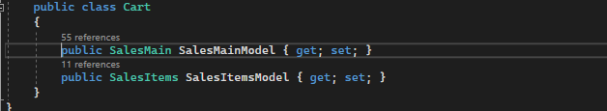

**Sales Controller:**

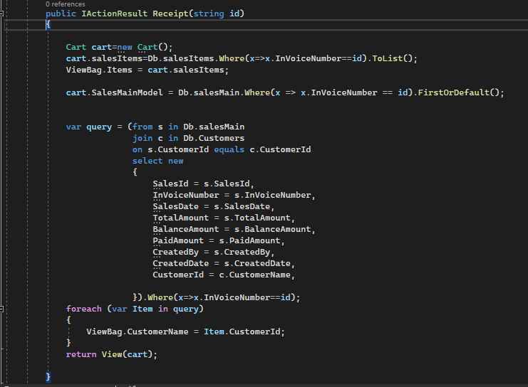

Where string **id** is the **Invoice Number** of the row of which we want to create receipt.

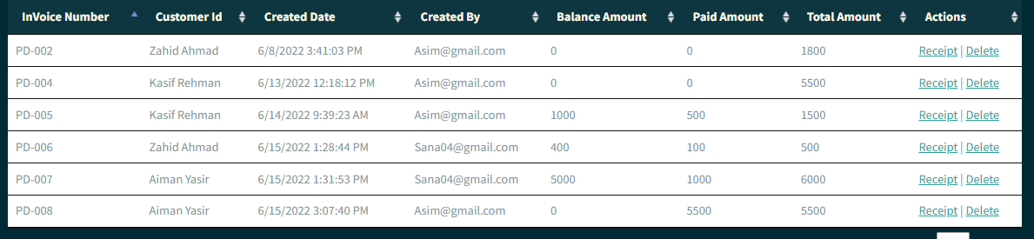

**id** is passed from above view called **viewitems**.



Receipt view also required data from both models. For that object of Cart Model is created to access data of both models.



To get record from SalesMain table having Invoice Number equal to string id.



To get list from SalesItem table having Invoice Number equal to id.



List of **salesItems** is passed to view using View Bag.

**CustomerId** in salesMain Model is in int as shown below:

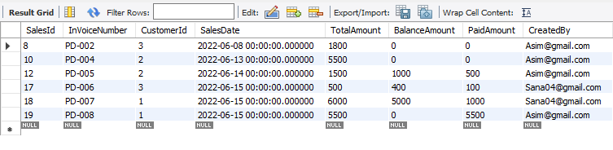

But we want **Customer Names** to be displayed on Receipt which are present in **CustomerTable**.

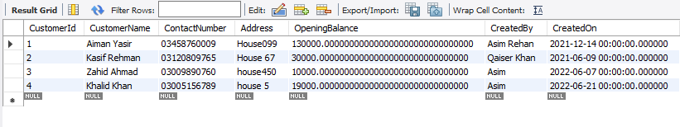

For that **Inner Join** is used

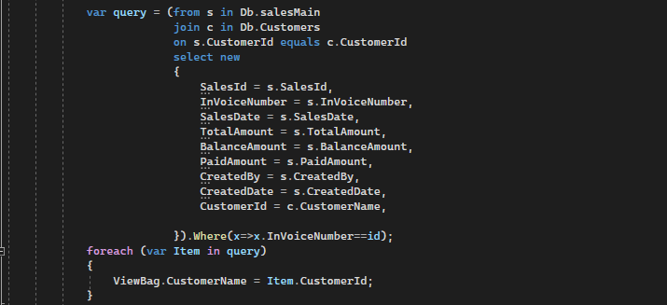

Customer Name is passed to view using ViewBag and cart object is passed to view.

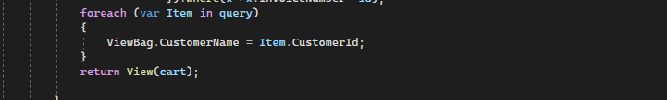

**Receipt View:**

Receipt view is designed using **DataTables** plug-in.

**JavaScript:**

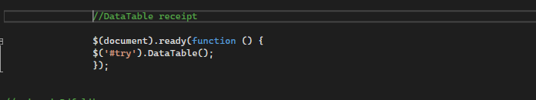

**Html:**

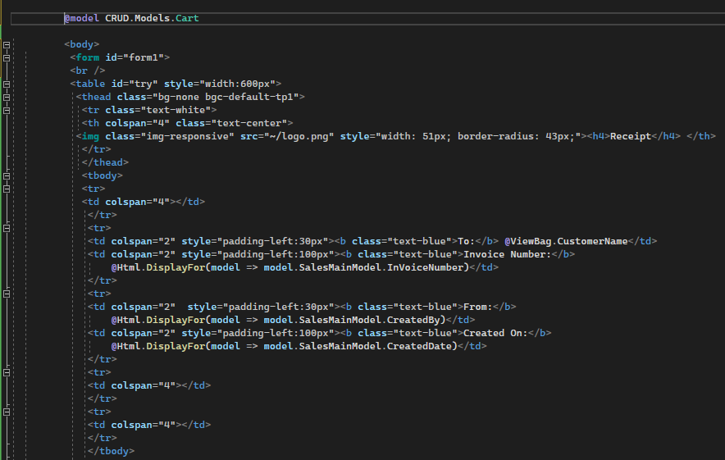

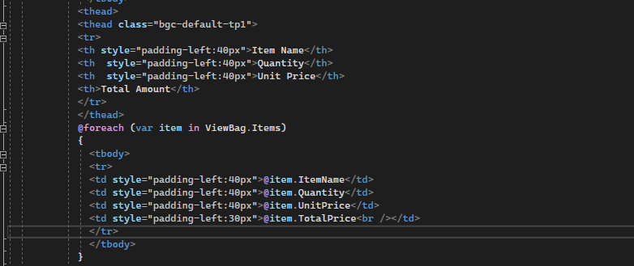

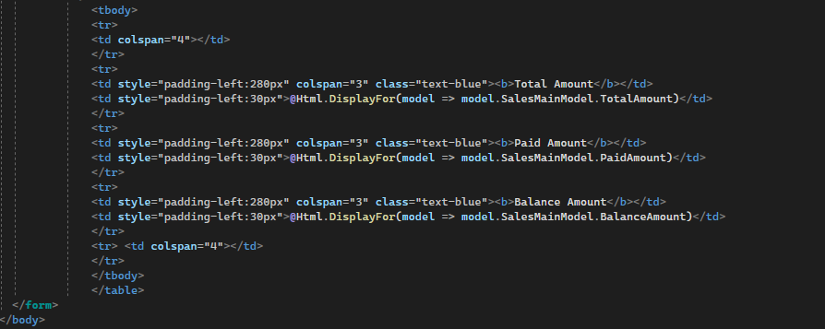

**Browser View:**

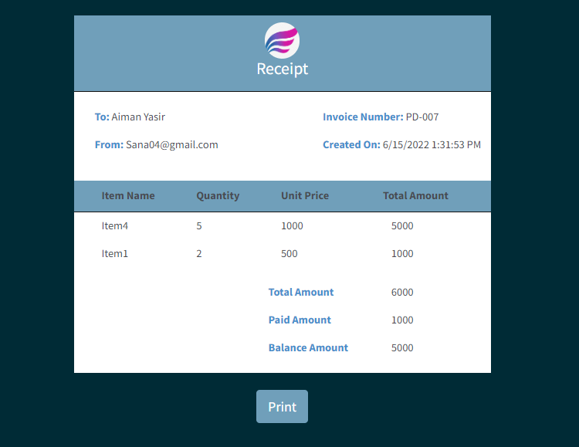

**Print Preview:**

Print preview of above receipt is created by clicking on the Print button using **jspdf** library.

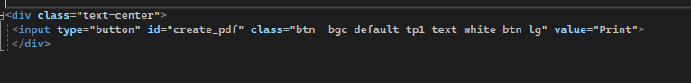

**JavaScript:**

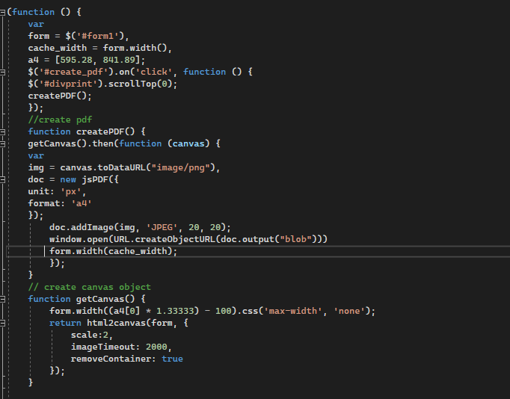

Print preview is shown below.

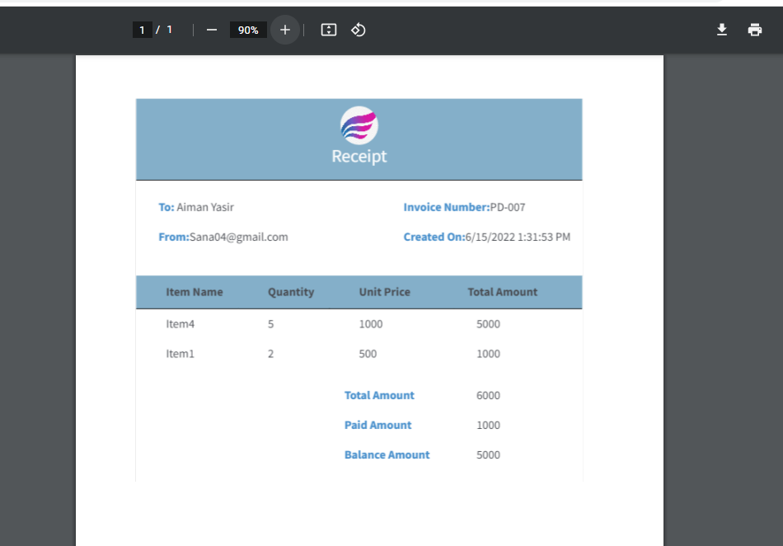

The Pdf is saved as print.pdf.